ALLIANCE IN MOTION GLOBAL, INC.
COMPANY POLICIES AND PROCEDURES

INTRODUCTION | 3
DEFINITION OF TERMS | 3
SECTION 1: AUTHORIZATION AS A DISTRIBUTOR | 5
1.1. Who may be a Distributor? | 5
1.2. How to become a Distributor? | 5
1.3. Entitlements of a Distributor | 5
1.4. Loyalty | 6
SECTION 2: THE DISTRIBUTOR | 6
2.1. One Individual Distributorship | 6
2.2. Husband and Wife Distributorship | 7
2.3. Legal Entities | 7
2.4. Relationship and Representation | 7
2.5. Proxy Distributorship | 8
2.6. Multiple Accounts | 8
2.7. Reselling of Accounts | 8
2.8. Prohibition on Bonus Buying | 8
2.9. Prohibition on Buy-Ins | 8
2.10. Managing the Accounts | 9
2.10.1. Inactive Account | 9
2.10.2. Transfer of Account | 9
2.11. Change of Sponsorship | 9
2.12. Indemnity Agreement | 10
2.13. Confidentiality Agreement | 10
2.13.1. Personal Information | 10
2.13.2. Confidential Information | 11
2.14. Termination of Distributorship | 11
2.14.1. Voluntary Termination | 11
2.14.2. Involuntary Termination | 11
2.15. Due Observance of Policies | 12
SECTION 3: THE SPONSOR | 12
3.1. Responsibility of the Sponsor | 12
3.2. Exclusive Territories | 12
SECTION 4: CODE OF CONDUCT AND ETHICAL STANDARDS | 13
CODE NO. 1: LOYALTY | 13
CODE NO. 2: PROTECTION OF REPUTATION | 13
CODE NO. 3: HONESTY IN DEALINGS | 13
CODE NO. 4: HONESTY AMONG MEMBERS | 13
CODE NO. 5: HUMILITY AND RESPECT | 14
CODE NO. 6: FAIRNESS | 14
CODE NO. 7: DECENCY | 14
CODE NO. 8: NON-TOLERANCE OF FRAUD | 15
4.1. Penalty for Violation of Section 4 | 15
TABLE OF CONTENTS
SECTION 5: MARKETING PLAN | 16
5.1. The Business | 16
5.2. Ways to Earn | 16
5.2.1. Retailing | 16
5.2.2. Direct Sponsoring | 16
5.2.3. Matched Sales Bonus | 16
5.2.4. Uni-Level Bonus | 18
5.2.5. Stair Step Bonus | 18
5.2.6. Royalty Bonus | 19
5.2.7. GA Max | 19
5.2.8. Flow Back | 20
5.2.9 Travel Incentives  5.2.10 Profit Sharing Incentive  5.3. Payment Schedule | 21
5.4. Promos | 22
5.5. Taxation | 22
5.6. Re-inventing the Marketing Scheme | 22
SECTION 6: PRODUCT SALES | 22
6.1. Product Maintenance | 22
6.2. New Product Policy | 23
6.3. Direct Sales Only | 23
SECTION 7: PRODUCT REFUND AND BUY BACK POLICY | 23
SECTION 8: PRODUCT EXCHANGE | 24
SECTION 9: BUY BACK PROCEDURE | 24
SECTION 10: ADVERTISING | 25
10.1. On Promotional Materials | 25
10.2. Websites | 25
10.3. Fairs and Trade Shows | 26
SECTION 11: GENERAL PROVISIONS | 26
11.1. Contract Changes | 26
11.2. Waivers and Exceptions | 26
11.3. Governing Law and Jurisdiction | 26
11.4. Severability | 27

INTRODUCTION

The rules and procedures embodied in this document are being implemented to regulate sales and marketing operations as well as prevent improper, illegal or abusive acts within the company. These policies shall govern the relationship between the Distributor and ALLIANCE IN MOTION GLOBAL, INC./ EMPOWERED CONSUMERISM, the Distributor and his clients, and such other matters related to these policies.

Every Distributor is expected to be knowledgeable of the following rules and abide by the same to ensure his or her success as well as that of the company.

DEFINITION OF TERMS

In all contractual agreements a Distributor signs with ALLIANCE IN MOTION GLOBAL, INC. and ALLIANCE IN MOTION GLOBAL, INC. published literature, unless the context otherwise requires, the following words and phrases shall have the following meanings:

“Empowered Consumerism (EC)”- is a duly registered business entity and a patented trademark that is being used by ALLIANCE IN MOTION GLOBAL INC. as its marketing platform. Empowered Consumerism and Alliance In Motion Global Inc. shall be used interchangeably in this manual.

“AIMcademy” – A training facility of ALLIANCE IN MOTION GLOBAL, INC. designed to help distributors to build their network effectively including those who do their business online. Aimcademy.com offers a wide range of information from the basic to the most advanced topics.

“Applicant” – A person who is interested to become an ALLIANCE IN MOTION GLOBAL, INC./EMPOWERED CONSUMERISM Distributor.

“Empowered Consumer Achievement Platform (ECAP)” – This is an advance training on the importance of Multi-Level Marketing (MLM) in relation to the business of ALLIANCE IN MOTION GLOBAL, INC./EMPOWERED CONSUMERISM and basic skills in doing the business.

“Business Center” – The venue where the Business Center Owner conducts seminars, trainings and direct selling of products in a specific area.

“Commercial Website” – www.EmpoweredConsumerism.com is the official website of ALLIANCE IN MOTION GLOBAL, INC. / EMPOWERED CONSUMERISM

“Commissional Points” – Points used in computing Uni-level and Stair Step commission.

“Unauthorized Re-sponsoring” – This is the Distributors’ act of transferring from one Distributors’ organization to another. This is strictly prohibited.

“Downline” – a sponsored distributor who eventually formed part of the network of the sponsor or upline, either directly sponsored by the latter or not.

“Direct Downline” – one directly invited by a sponsor to avail of the Global Package to become an independent distributor.

“Distributor” – Any person whose application has been duly approved by the management of ALLIANCE IN MOTION GLOBAL, INC./EMPOWERED CONSUMERISM. A Distributor may become a Silver Executive (SE), Gold Executive (GE) and Global Ambassador (GA) upon qualifying as such according to the approved and authorized marketing plan of ALLIANCE IN MOTION GLOBAL, INC./EMPOWERED CONSUMERISM.

“Distributorship” – The authorization by ALLIANCE IN MOTION GLOBAL, INC./EMPOWERED CONSUMERISM to become its registered distributor.

“Distributor Application Form (DAF)” – When a person desires to become a distributor of ALLIANCE IN MOTION GLOBAL, INC./EMPOWERED CONSUMERISM he/she must sign the Distributor Application Form, which contains the terms and conditions of the company. If a person registers as a distributor online or via the company website, an applicant is considered to have read, understood and agreed to the policies of the company.

“Distributors Price (DP)” – The price of products set for registered distributors of Alliance in Motion Inc./EMPOWERED CONSUMERISM.

“Distributors Tracking Center (DTC)” – This is commonly known as the “Distributors’ Website”. This is where a distributor can view and manage his/her account reflecting the personal information, genealogy, income and encashment of each Distributor. The DTC is accessed by clicking on the “Member’s Login” link in the commercial website of ALLIANCE IN MOTION GLOBAL, INC./EMPOWERED CONSUMERISM.

“Flush Out” – The safety measure in the Matched Sales/Binary System, wherein a distributor/sponsor will only be paid for a maximum of sixteen (16) pairs/matched sales per day or eight (8) pairs per cycle. This mechanism is followed to balance the methods of earning through recruiting new distributors and direct sales of products. See attached Marketing Plan for more details.

“EC Package " – This is commonly known as the BUSINESS KIT or the start-up sales kit for a New Distributor. Products included in the package may vary quarterly or semi-annually as part of promotional activities.

“Sales Force” – A Distributor may have two (2) sales forces when he starts his network under one account; the Left Sales Force and the Right Sales Force. For each sales force, the Distributor may have as many downlines as he or she can manage.

“Network” – This consists of the Distributors’ organization/s or sales forces, which include the entirety of the Distributors’ downlines.

“New Empowered Consumer Orientation (NECO)” – This is a seminar on how to get started.

“Empowered Consumer Orientation (ECO)” – This is the marketing plan presentation about the EC Package, benefits, products and compensation plan.

“Positional Points” – Points used in computing current positions as Silver Executive (SE), Gold Executive (GE) or Global Ambassador (GA).

“Sponsor” – A distributor who introduces and registers a person to ALLIANCE IN MOTION GLOBAL, INC./EMPOWERED CONSUMERISM, who eventually becomes a distributor by virtue of the company’s acceptance of a Distributor’s Application. Sponsors are commonly known as “Direct Uplines”. A sponsor is responsible for training and supporting his downlines in the conduct of business.

“Suggested Retail Price (SRP)” – The selling price set for consumers.

“Technical Training” – Training on the terms & conditions and code of conduct of the company, how to manage the distributors tracking center (DTC), how to encode recruits’ information and how to manage flush out.

SECTION 1
AUTHORIZATION AS A DISTRIBUTOR

1.1. WHO MAY BE AN EMPOWERED CONSUMERISM DISTRIBUTOR?

Any person at least eighteen (18) years old, a corporation, partnership or legal entity may apply and become an ALLIANCE IN MOTION GLOBAL, INC./EMPOWERED CONSUMERISM Distributor. An applicant who wishes to become a Distributor must be capable of entering into a contract in accordance with the laws of the Philippines and must comply with all legal requirements for conducting business in the Philippines.

1.2. HOW TO BECOME AN ALLIANCE IN MOTION GLOBAL, INC./EMPOWERED CONSUMERISM DISTRIBUTOR?

1.2.1. To become an ALLIANCE IN MOTION GLOBAL, INC./EMPOWERED CONSUMERISM Distributor, an applicant must purchase the EC Package.

1.2.2. The applicant must then fill-out and sign the Distributor Application Form found in the EC Package or register on the Distributors’ website.

1.2.3. An applicant shall read the Terms and Conditions of the company, indicated in the ALLIANCE IN MOTION GLOBAL, INC./EMPOWERED CONSUMERISM Distributor Application Form (DAF) or Distributor website, and shall agree to abide by all their provisions.

1.2.4. The accomplished DAF or online registration form shall signify the Distributor’s acceptance of the terms and conditions of the company, which shall serve as the contract between the Distributor and ALLIANCE IN MOTION GLOBAL, INC./ EMPOWERED CONSUMERISM.

1.2.5. The ALLIANCE IN MOTION GLOBAL, INC./EMPOWERED CONSUMERISM Distributor Application Form (DAF) must be submitted immediately upon completion to the head office or any of ALLIANCE IN MOTION GLOBAL,INC./EMPOWERED CONSUMERISM Business Centers. The authorization is effective upon submission of the DAF or upon registration with the Distributor website.

1.2.6. The placing of order for products with ALLIANCE IN MOTION GLOBAL, INC./EMPOWERED CONSUMERISM is a reaffirmation of such commitment to abide by the company policies and procedures.

1.2.7 Persons below 18 years old may become Authorized Distributors provided they submit a written parents’ or legal guardian’s consent, subject to the approval by the Management.

1.3. ENTITLEMENTS OF A DISTRIBUTOR

1.3.1. As an ALLIANCE IN MOTION GLOBAL, INC./EMPOWERED CONSUMERISM Distributor, he/she/it can now engage in the direct selling of all ALLIANCE IN MOTION GLOBAL, INC./EMPOWERED CONSUMERISM products and shall be entitled to corresponding commissions, rebates, discounts and privileges given by the company.

1.3.2. Resigned or terminated Distributors, however, are no longer entitled to avail of the aforementioned commissions and benefits.

1.3.3. The rights and privileges that come with the Identification Card issued by the company cannot be transferred to another person or legal entity.

1.4. LOYALTY

Distributors shall remain loyal to the company and its policies and are not allowed to join any other Multi-Level Marketing (MLM) companies directly competing with ALLIANCE IN MOTION GLOBAL, INC./EMPOWERED CONSUMERISM while they are Distributors in the latter.

SECTION 2
THE DISTRIBUTOR

2.1. ONE INDIVIDUAL DISTRIBUTORSHIP

Only one individual may apply for a Distributorship and sign the Distributor Application Form or register online with the Distributor website.

2.2. HUSBAND AND WIFE DISTRIBUTORSHIP

2.2.1. A husband and wife may become individual distributors following the procedure above, PROVIDED, they register under THE SAME GROUP. This means that either the husband or wife becomes the upline or downline of the other spouse.

2.2.2. In the event that the spouses have already been previously registered under different networks/groups, either spouse must choose in which group he/she wishes to belong, PROVIDED, the transferring spouse does not have any downlines. The transferring spouse will be given a period of thirty (30) days from notice to choose his/her group of preference, after which period management shall exercise its discretion on the transfer. The spouse required to transfer shall not be permitted to have any downlines pending such transfer.

2.2.3 In the event of marriage between two members belonging to two different groups, the spouses shall decide whether to maintain their accounts separately, or to request for termination of one account for the purpose of transferring to his/her spouse’s group.

2.2.4. The transfer contemplated in the previous section shall be accomplished by purchasing another Global Package from a sponsor in the group to which the concerned spouse shall transfer.

2.2.5. The spouses shall not be permitted to register under sponsors from different groups. Spouses found guilty of violating or circumventing this policy shall not be allowed to have downlines in the unauthorized registration of either of the spouses under this rule. Any production created from such downlines of both spouses shall be forfeited and be credited to the nearest upline of the liable spouse.

2.2.6 In the event that either spouse joins a competing and other MLM Company, the Distributorship of both spouses in ALLIANCE IN MOTION GLOBAL, INC./EMPOWERED CONSUMERISM will be deactivated based upon the policies of the Company.

2.3. PARTNERSHIPS, CORPORATIONS AND OTHER LEGAL ENTITIES

A duly registered Partnership, Corporation or other legal entities may become an authorized Distributor. Such Distributorship may be approved by ALLIANCE IN MOTION GLOBAL, INC./EMPOWERED CONSUMERISM on a case-to-case basis. The duly authorized representative of a legal entity must submit a secretary’s certificate or its equivalent evidencing that the representative is authorized by a board resolution to apply for Distributorship with ALLIANCE IN MOTION GLOBAL, INC./EMPOWERED CONSUMERISM and such other documents as the Management may require.

2.4. RELATIONSHIP AND REPRESENTATION

ALLIANCE IN MOTION GLOBAL, INC. members are considered “Independent Distributors” and as such, there shall be no employer-employee relationship between ALLIANCE IN MOTION GLOBAL, INC./EMPOWERED CONSUMERISM and the members. ALLIANCE IN MOTION GLOBAL, INC./EMPOWERED CONSUMERISM shall not be responsible for any misrepresentation made by its Distributors.

No Distributor possesses the authority to bind ALLIANCE IN MOTION GLOBAL, INC./ EMPOWERED CONSUMERISM to any obligation.

Nonetheless, ALLIANCE IN MOTION GLOBAL, INC./EMPOWERED CONSUMERISM reserves the right to require the members to report physically in the office when deemed necessary.

2.5. ON PROXY DISTRIBUTORSHIP

A Distributorship, or any resulting group, created or operated by proxy, whether intentionally or inadvertently, is not allowed, and shall be adjusted for compliance with company policies and procedures.

2.6. MULTIPLE ACCOUNTS

ALLIANCE IN MOTION GLOBAL, INC./EMPOWERED CONSUMERISM Distributors shall each be allowed to purchase only up to a maximum of fifteen (15) accounts registered under his/her name for the Empowered Consumerism Package worth ₱8,999. Any registration above this limit is considered a violation of this provision and the Company reserves the right to deactivate accounts in excess of the allowed number of accounts.

2.7. ON RE-SELLING OF ACCOUNTS

Re-selling of accounts of a Distributor to any individual is strictly NOT ALLOWED whether he or she belongs to the same group, crossline, upline, downline, relative or otherwise.

2.8. PROHIBITION ON BONUS BUYING

The following acts constitute bonus buying and are strictly prohibited:

  - Registration of individuals without the knowledge of and/or execution of an Independent Distributor Application Form by such individual;
  - The fraudulent registration of an individual as a Distributor (i.e. without purchasing the EC/ED Package) without the knowledge of the said individual;
  - The registration or attempted registration of non-existent individuals as Distributors to qualify for bonus or commissions;
  - Any other ways or mechanisms by which strategic purchases are made to maximize commissions or bonuses when a Distributor does not have a bona fide use for the products purchased.

2.9. PROHIBITION ON BUY-INS

Buy-In is the purchase of products in excess of immediate sales needs. Such an act is not permitted and will lead to the termination of the Distributors’ account.

To discourage any Distributor from bonus buying and buy-ins, the company reserves the right not to pay any bonus or commission and forfeit any incentive to the Distributor and uplines who benefited from such transactions. Distributors who took part in the bonus buying and/or buy-in will be dealt with severely, which may include termination and/or legal action for damages.

2.10. MANAGING THE DISTRIBUTORSHIP ACCOUNTS

The Distributor is responsible for keeping the information in his accounts accurate. ALLIANCE IN MOTION GLOBAL, INC./EMPOWERED CONSUMERISM reserves the right to take action, which may include the termination of the account, in the event that the company determines that false or inaccurate information was given.

2.10.1. INACTIVE ACCOUNT

An account is considered inactive when there has been no personal product purchase, personal sponsoring nor income encashment for a period of six (6) months.

2.10.2. ON TRANSFERRING OF ACCOUNT / SUCCESSION

Upon the death of the Distributor, his/her account/s shall be transferred to his or her heirs subject to the laws governing wills and succession. Within sixty (60) days from the death of the Distributor a lawful heir/s or transferee/s shall submit a letter request for transfer of account with attached proof of heirship, extrajudicial-partition, affidavit of self-adjudication, holographic will, notarial will, or other similar documents supporting the claim for the deceased Distributor’s account. The transfer of an account to heir or heirs owning the account in common shall be subject to laws and procedures governing wills and succession. The heir/s or claimant/s upon transfer of the account under their names shall undertake to render ALLIANCE IN MOTION GLOBAL, INC./EMPOWERED CONSUMERISM free and harmless from any claim, action, suit, or liability arising from or relating to the transfer or grant of the account to lawful heir/s or claimant/s.

Upon written request and approval by ALLIANCE IN MOTION GLOBAL, INC./ EMPOWERED CONSUMERISM a Distributor may voluntarily pass on to his/her designated assignee all rights including rights to income and marketing position, together with Distributorship responsibilities and obligations.

The Company reserves the right to approve such voluntary transfers or assignments only on the basis of highly meritorious reasons.

2.11. CHANGE OF SPONSORSHIP/ TRANSFERRING TO ANOTHER GROUP

2.11.1. It is against company policy for any distributor to change sponsors. ALLIANCE IN MOTION GLOBAL, INC./EMPOWERED CONSUMERISM will only consider the first valid registration and any subsequent applications or registrations will not be allowed.

2.11.2. A Distributor may only change sponsors if he/she has been inactive for at least six (6) months. Inactivity means a Distributor has not purchased any products nor sponsored any individual and has not been physically active for six (6) months.

2.11.3. It is strictly prohibited to engage in any activity that involves the soliciting of any Distributor to transfer/move to a different group by making offers such as, but not limited to, free slots, marketing support, financial support, etc.

2.11.4. Any Distributor who sponsors active distributors from his/her own group or other groups or crosslines is considered as unauthorized re-sponsoring and shall be penalized by management accordingly.

2.11.5. Only complaints/concerns from active distributors affected by the transfers stated above shall be entertained by management.

2.12. INDEMNITY AGREEMENT

All Distributors agree to assure ALLIANCE IN MOTION GLOBAL, INC./EMPOWERED CONSUMERISM officers, agents and directors that the latter be held harmless against any claim, demand, liability, loss, cost or expense, including but not limited to legal fees, that may arise from, relating, or concerning the Distributor or the Distributor’s conduct of business or transactions.

2.13. CONFIDENTIALITY AGREEMENT

2.13.1. Authorization to Use Personal information of the Distributor

The Distributor authorizes ALLIANCE IN MOTION GLOBAL, INC./EMPOWERED CONSUMERISM to:

- Transfer and disclose personal and/or confidential information, which:
  - was provided to the Company in connection with the Distributorship and the resulting group; or
  - has been developed as such as a result of the Distributor’s activities
to:
a. its parent and affiliated companies wherever located;
b. applicable government agencies or regulatory bodies if required by law.
c. the distributor’s upline or sponsor when the Company determines it is appropriate. However, the Distributor will have the option to block the transfer of certain information that may be provided to the upline Distributors.

- Use personal information for Distributor recognition and the Company’s literature (such as testimonials, etc.), unless the Distributor requests in writing that the Company not do so;

Any other disclosure, apart from the above will not be permitted.
2.13.2. Non-disclosure of Confidential Information from the Company

ALLIANCE IN MOTION GLOBAL, INC./EMPOWERED CONSUMERISM provides its Distributors the necessary information for the sole purpose of furthering the company’s business such as, but not limited to the sale of company products, and the sponsoring and training of applicants and downlines in the conduct of business. However, access to said information is conditioned upon the Distributors’ commitment of non-disclosure and confidentiality.

The Distributor will not, for any reason, disclose the following information on his behalf, or on behalf of another:

- Any confidential information obtained during your Distributorship was in effect, related to or contained in the network to any third party directly or indirectly;
- Any password or access codes of the company to any third party directly or indirectly.

The obligations under this section shall survive even after the termination of the Distributor’s account.

2.14. TERMINATION OF DISTRIBUTORSHIP

A Distributor’s authorization to distribute ALLIANCE IN MOTION GLOBAL, INC./EMPOWERED CONSUMERISM packages and products is for life, unless terminated voluntarily or involuntarily.

2.14.1. Voluntary Termination

A Distributor is considered to have voluntarily terminated his distributorship upon receipt by the ALLIANCE IN MOTION GLOBAL, INC./EMPOWERED CONSUMERISM. Head Office of his/her written notice of resignation. He/She is thereafter disallowed to register under another networking company or any similar company in direct competition with ALLIANCE IN MOTION GLOBAL, INC./EMPOWERED CONSUMERISM for a period of six (6) months in cities, municipalities, or places of the Philippines or other countries where ALLIANCE IN MOTION GLOBAL, INC. has Business Center/s at the time of the effectivity of the termination.

2.14.2. Involuntary Termination

ALLIANCE IN MOTION GLOBAL, INC./EMPOWERED CONSUMERISM reserves the right to terminate the account of any Distributor who violates the terms and conditions in the Distributor Application Form or online registration with the Distributor website, ALLIANCE IN MOTION GLOBAL, INC./EMPOWERED CONSUMERISM policies and procedures, or for any other just cause. Involuntary termination is effective when the Distributor receives actual notice of the termination. He/She is thereafter disallowed to register under another networking company or any similar company in direct competition with ALLIANCE IN MOTION GLOBAL, INC./EMPOWERED CONSUMERISM for a period of six (6) months in cities, municipalities, or places of the Philippines or other countries where ALLIANCE IN MOTION GLOBAL, INC./EMPOWERED CONSUMERISM has Business Center/s at the time of the effectivities of the termination. A terminated Distributor may become a member of ALLIANCE IN MOTION GLOBAL, INC./ EMPOWERED CONSUMERISM again after six months depending upon the nature of his/her termination and subject to the approval of the Management. The Company reserves the right not to allow terminated Distributor to become an Authorized Distributor again if it deems disadvantageous to its stakeholders.

2.15. DUE OBSERVANCE OF COMPANY POLICIES

To preserve the integrity of the company’s business, Distributors must observe the company’s rules, regulations and Code of Conduct and Ethical Standards. Violation of these rules will mean automatic deactivation, suspension or termination of account, depending on the offense. As part of the company’s due process in its effort to investigate complaints arising from conflicts, the company reserves the right to deactivate accounts of the Distributor who allegedly violated provisions as stated in the Company Policy Manual. After the deactivation of an account, the Distributor will be given two (2) months to clarify the issues pertaining to the deactivation by reporting to the Management in person. Non-compliance will lead to the permanent deactivation of the account.

SECTION 3
THE SPONSOR

3.1. RESPONSIBILITY OF THE SPONSOR

Sponsors are responsible for their direct downlines in ensuring that they are properly trained with respect to ALLIANCE IN MOTION GLOBAL, INC./EMPOWERED CONSUMERISM products, policies and procedures, marketing plan and sound business practices. Such responsibility includes:

  - TRAINING by making sure that the downline attends all the required trainings and seminars of the company;
  - COMMUNICATING to entertain the downline’s inquiries and advising them regarding the proper steps/strategies to take;
  - UPDATING by informing the downline regarding new policies and developments in the company.

3.2. EXCLUSIVE TERRITORIES

The Distributor may extend his or her sponsoring activities to any country where ALLIANCE IN MOTION GLOBAL, INC./EMPOWERED CONSUMERISM exists and to other territories as may be approved by the management. However, distributors are only allowed to purchase their products from any BCO’s in their home base and it is strictly prohibited for any distributor to send products to their group in other countries where ALLIANCE IN MOTION GLOBAL, INC./EMPOWERED CONSUMERISM is operating, as this will directly compete with the international BCO’s. Any sales and commissions, bonus or incentives earned by any distributor from such a transaction will be forfeited by the management.

SECTION 4
CODE OF CONDUCT AND ETHICAL STANDARDS

CODE NO. 1: LOYALTY TO THE COMPANY

All members shall at all times, remain loyal to the company and its policies being issued from time to time. They must not commit acts, which include but are not limited to:

- Joining, representing, associating, sponsoring, recruiting, conspiring in any mode or form for the benefit or advantage of companies, business sales forces, partnership or individual, directly competing with ALLIANCE IN MOTION GLOBAL, INC./ EMPOWERED CONSUMERISM either locally or abroad;

b) Introducing, presenting, selling, promoting, nor offering in any manner another MLM company’s products, services, businesses, marketing programs and plans or a combination thereof, whether tangible or intangible.

Note: If the Distributor/s was confirmed to have joined another MLM company, 2nd offense penalty provided below will automatically apply.

CODE NO. 2: PROTECTION OF COMPANY REPUTATION

In consideration of the benefits and privileges given by the Company, all members must not make nor encourage written or oral remarks or statements, which tend to discredit and disrepute the company, its centers or any of its service branches and its officers, agents or representatives.

CODE NO. 3: HONESTY IN ALL DEALINGS

All Distributors are strictly enjoined to be professionals in all acts and bearings, dealings or transactions. They must not make any false statements, such as, but not limited to misrepresentation, exaggeration, disinformation, vain promises, introducing fake or spurious products or services, or circumventing the marketing plans or programs of the company.

CODE NO. 4: HONESTY AMONG FELLOW MEMBERS

All Distributors are strictly enjoined to be honest and credible in all their deeds by not committing acts against the company or fellow members, which are but not limited to:
- Imitating or counterfeiting any handwriting, or signature;
- Causing it to appear that a member has participated in any act or activity when he/she did not in fact so participate;
- Alluding or pointing to members who have participated in any act, activity or statements other than those made by them;
- Inserting false statements in a narration of facts such as those in the affidavit, deed and other documents similar thereto;
- Changing true dates;
- Modifying a genuine document, which alters or changes its meaning; or
- Issuing in an authenticated form a document purporting to be a copy of an original document when no such original actually exists;

CODE NO. 5: HUMILITY AND RESPECT TOWARDS MEMBERS OF THE COMPANY

All Distributors are strictly enjoined to observe humility and respect towards fellow Distributors, members, officers and employees of the company, by not committing directly or indirectly any acts, which are but not limited to rudeness, disrespect and discourtesy.

*First Offense - One (1) month deactivation of all the accounts with the forfeiture in favor of the company of all benefits, privileges, commissions and other remunerations either monetary or any kind, which accrued at the time of the commission of the violation.

*2nd Offense - Six (6) months deactivation of all the accounts with the forfeiture in favor of the company of all benefits, privileges, commissions and other remunerations either monetary or any kind, which accrued at the time of the commission of the violation.

*3rd Offense - Perpetual deactivation of all the accounts, which carries with it the forfeiture of all benefits, privileges, commissions and other remunerations either monetary or any kind in favor of the company, which accrued at the time of the commission of the violation.

CODE NO. 6: FAIRNESS TOWARDS FELLOW DISTRIBUTORS

All Distributors are strictly enjoined to have a sense of equality and sincerity toward fellow Distributors by not interfering with the sponsoring activities of their fellow Distributors to the latter’s prejudice. While it is generally the discretion of the recruit under whose sponsorship, he/she will register, Distributors are strictly prohibited from influencing other Distributors’ recruits to register under sponsors apart from the ones who invited them.

However, after six (6) months from the time a recruit is introduced to ALLIANCE IN MOTION GLOBAL, INC./EMPOWERED CONSUMERISM and no registration has been accomplished by the original sponsor, another Distributor may sponsor him or her.

CODE NO. 7: DECENCY, GOOD MORALS AND BEHAVIOR

All Distributors are strictly enjoined to observe decency and good behavior by not committing any immoral act or conduct, which tends to debase company policies and good morals within the company premises, its centers or service branches.

Distributors are strictly prohibited from influencing, obstructing or inducing the spouses’ choice to transfer from one group to another or to circumvent the policy regarding such transfer. (See Section 2.2 on Husband and Wife Distributorship)

*1st Offense - Perpetual deactivation of all the accounts, which carries with it the forfeiture of all benefits, privileges, commissions and other remunerations either monetary or any kind in favor of the company, which accrued at the time of the commission of the violation.

CODE NO. 8: NON-TOLERANCE OF FRAUDULENT ACTIVITIES

All Distributors are strictly enjoined not to commit any fraudulent act or false pretenses directly or indirectly, to the prejudice of the company or fellow member by not committing acts, which are but not limited to:

      - For internal control of the company:
- Using fictitious name, or dummy, or by other deceitful means purportedly to obtain personal gain and interest;
- Issuing a check to a fellow Distributor or to the company when he/she/it has no funds or are insufficient to cover the amount of the check;
- Incurring obligation to a fellow Distributor or to the company and evading the performance thereof;
- Non-issuance of the COMPLETE SET OF REGISTRATION PACKAGE and/or NOT ENCODING the New Distributor;
- Soliciting large sums of money from persons who purport to be investors;
- Unauthorized re-sponsoring or Transferring to other group, except as authorized by the Company;
- Openly or discreetly giving gifts to management and staff to gain personal favors.

- For Selling of Products:

    - By altering the quality, fineness or weight of any product pertaining to the business of the company;
    - ONE PRICE POLICY: Selling of ALLIANCE IN MOTION GLOBAL, INC./ EMPOWERED CONSUMERISM products below the standard retail price set by the company is strictly prohibited. Anyone who is guilty of selling the products below the standard price to both customers and distributors will be subject to termination and legal action from the company for damages.

*1ST Offense - Perpetual deactivation of all the accounts, which carries with it the forfeiture of all benefits, privileges, commissions and other remunerations either monetary or any kind in favor of the company, which accrued at the time of the commission of the violation.

4.1. PENALTY FOR VIOLATION OF SECTION 4: CODE OF CONDUCT AND ETHICAL STANDARDS

The Company imposes the following penalties for violation of Section 4, unless otherwise indicated in the prior provisions:

*1st Offense - Six (6) months deactivation of all the accounts with the forfeiture in favor of the company of all benefits, privileges, commissions and other remunerations either monetary or any kind, which accrued at the time of the commission of the violation.

*2nd Offense - Perpetual deactivation of all the accounts, which carries with it the forfeiture of all benefits, privileges, commissions and other remunerations either monetary or in kind in favor of the company, which accrued at the time of the commission of the violation.

SECTION 5
MARKETING PLAN

5.1. THE BUSINESS OF ALLIANCE IN MOTION GLOBAL, INC.

The hybrid Marketing Plan of ALLIANCE IN MOTION GLOBAL, INC./EMPOWERED CONSUMERISM is a combination of Binary, Uni-level and Stair Step plan. The business consists of direct selling of products and the sharing of the business plan to prospective clients. A person desiring to enter into the business of ALLIANCE IN MOTION GLOBAL, INC./EMPOWERED CONSUMERISM has to purchase a Global Package.

5.2. WAYS TO EARN IN ALLIANCE IN MOTION GLOBAL, INC.

ALLIANCE IN MOTION GLOBAL, INC./EMPOWERED CONSUMERISM gives its Distributors seven (7) simultaneous ways to earn as follows:

5.2.1. Retailing

Distributors can earn by simple retail sales of ALLIANCE IN MOTION GLOBAL, INC./EMPOWERED CONSUMERISM Products. Distributors have a lifetime twenty five percent (25%) to fifty percent (50%) discount on all products. This is called the Distributor Price (DP). They may then sell the products at a higher price, which should not be below the Suggested Retail Price (SRP), pursuant to the One Price Policy.

5.2.2. Direct Sponsoring

For every new person that a Distributor sponsors, he/she earns a Direct Referral Bonus of US$14* and gets Php700 or 1200 product / binary points.

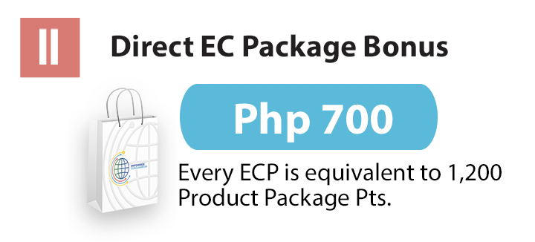

5.2.3. Matched Sales Bonus

This is also known as the Binary Program. Upon becoming a Distributor, the latter can form two (2) sales forces under his account, the Left Sales Force and the Right Sales Force. For each sales force, there can be several levels. To earn from this system, each level from the Left Sales Force and each level from the Right Sales Force must have a total of 1,200 points, which then reflects 2,400 points when combined. A Distributor immediately earns a Matched Sales Bonus of US$36 for every 2,400 combined sales force points up to 800th pair and a Matched Sales Bonus of US$30 for every 2,400 combined sales force from 801st pair onwards.

Distributors who have monthly income of more than Php 50,000 (1,000 USD) shall be entitled to Gift Certificates (GC) every 5th Matched Sale (pair) that can be converted to Travel Reward, Appliance/Gadget Reward, and Luxury Item Reward depending upon the company’s announcement.

Distributors who have monthly income of less than Php 50,000 (1,000 USD) shall have Product GC every 5th Matched Sale.

For this system, it is important for the company to maintain a balance in both recruiting new Distributors and selling of its products. A Distributor is not allowed to simply pull numerous recruits into the business and earn solely on the basis of the number of people he or she sponsors. This is why ALLIANCE IN MOTION GLOBAL, INC./EMPOWERED CONSUMERISM utilizes the “Flush-out” system. The “flush-out” system works by allowing only sixteen (16) matched sales per day, divided eight (8) matched sales for two (2) time intervals or cycles.

16 Matched Sales per Day = (8 Matched Sales per Cycle) x (2 cycles per day)

1st Cycle : 12:00 am – 11:59am
2nd Cycle : 12:00pm – 11:59pm

It is important to note that entering a sixteen (16th) match within the same cycle will result to a “flush-out” of all the points accrued from the sixteen (16th) match and he/she then goes back to zero points. However, the fifteen (15) matched sales will not be affected and will be converted to income immediately.
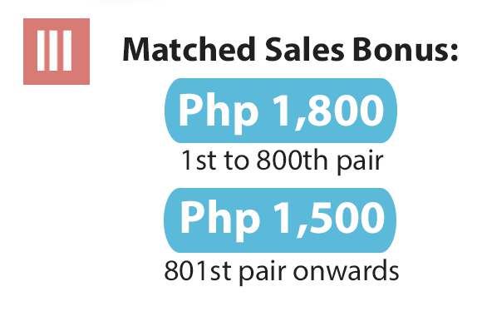

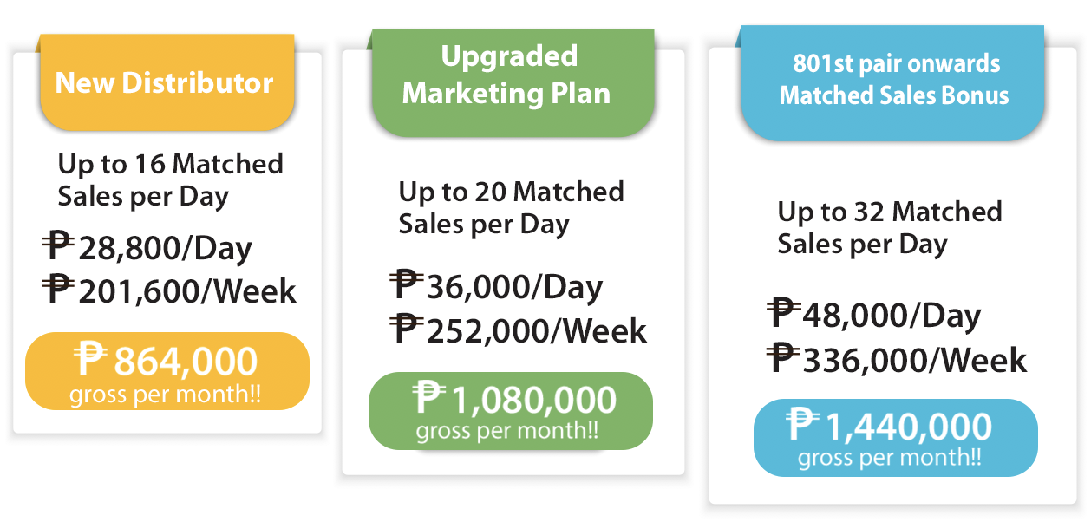

*RATES ARE BASED IN PESO (PHP), CONVERTED TO YOUR LOCAL CURRENCY

Diagram 1. Matched Sales Bonus Mechanism

5.2.4. Uni-level Bonus

Under this system, a Distributor can have several levels or downlines. From the product sales of each of his or her downlines, he or she earns five percent (5%) of product points. However, a Distributor can only earn up to his tenth (10th) level.

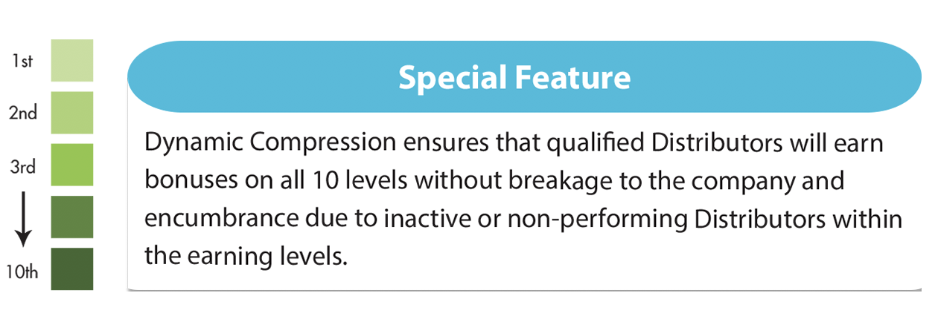
The special feature of this scheme is the Dynamic Compression. This mechanism ensures that qualified Distributors will earn bonuses on all 10 levels without breakage to the inactive or non-performing Distributors within the earning levels. If among the 10 levels, one (1) level is inactive, the latter will not be counted as a level. Instead, the eleventh (11th) level will take the place of the tenth (10th) level, and so on.

DIAGRAM 2. UNI-LEVEL EARNING MECHANISM

5.2.5. Stair Step Bonus

The benefit of becoming an Executive Distributor is the percentage of income commission that he or she derives from the total sales volume of his or her downlines.

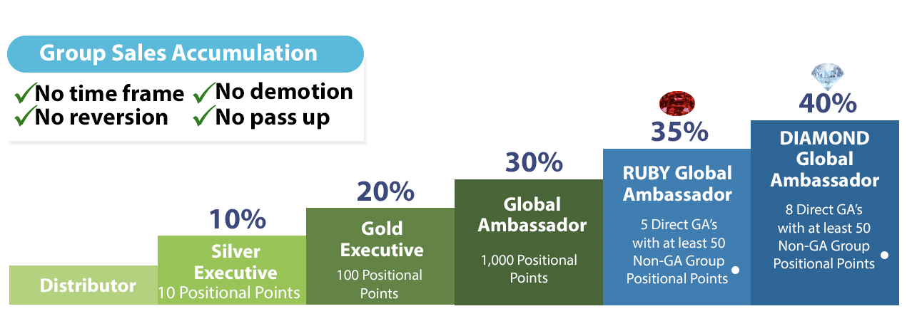
TABLE I. STAIR STEP BONUS MECHANISM

Royalty Bonus

When a Global Ambassador’s downlines achieve the Global Ambassador rank, he/she gets an additional 2% percent of income from the total group sales volume of the Global Ambassador and Non-Global Ambassador downlines. The income is limited to five (5) Global Ambassador downlines referred to as the first to the fifth generation Global Ambassadors.

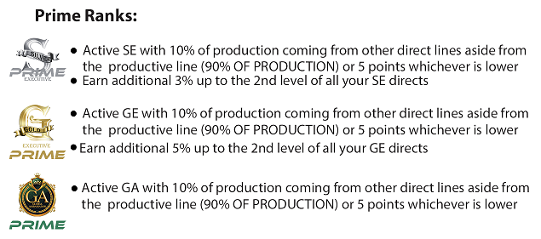

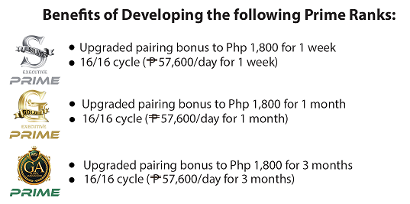

5.2.6. UNI-PAY PLAN
Distributor will enjoy commission from 1st level up to the 20th level, following their stair-step genealogy (same name compression).

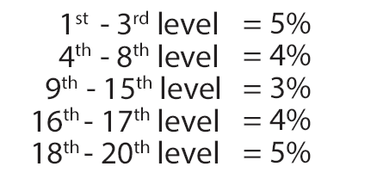
*Distributor must be in a prime rank to enjoy and earn commission from 11th level to 20th level.

5.2.7 FLOW BACK POINTS

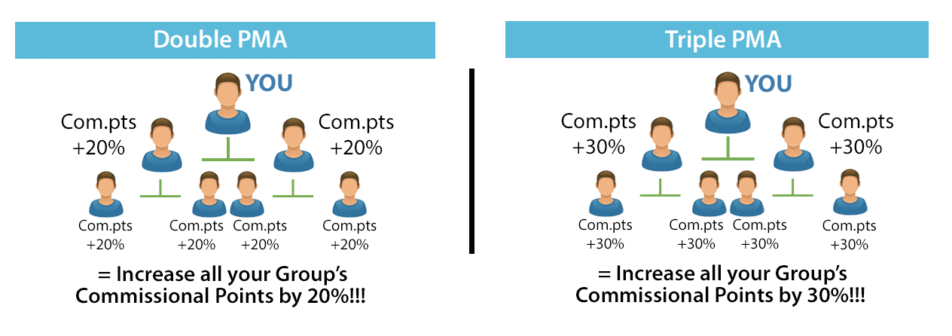
Do double or triple Personal Monthly Achievement and increase your commissional points by 20% - 30% more.
ADD ON FEATURES :

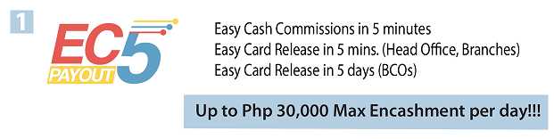



DIAGRAM 3. ROYALTY BONUS MECHANISM (GLOBAL AMBASSADOR)

5.2.9. Travel Incentives

Each Distributor may be entitled to a trip to the United States of America upon meeting the following conditions:

    - PERSONAL SALES
- Must have two (2) positional points from personal re-order maintenance per month or 24 positional points every month from January to December of the qualifying year;
- Complete Phyto Energizer product re-orders only; GC not included as maintenance.

    - 1 NEW DIRECT SPONSORING
      - Must have at least 30 points group sales
      - Must have at least 30 pairs at the end of the qualifying period

    - 1 NEW DIRECT SPONSORING
      - Must be promoted to Gold Executive Rank on or before the end of the qualifying period
      - Must have at least 100 pairs.
      - The GE must develop 3 new directly sponsored SILVER EXECUTIVES. Points of which are not included to the 100 points accumulated points of the GE.
      - Must have personal re-order maintenance of 0.3334 positional points for at least 3 months. (Cash only)
      - Must have at least 30 positional points (group product re-order quarterly).

Note:
- POS sales for the promo period only are considered for this incentive.
- GC positional points are not included for group or personal points.
- Travel incentives to other destinations are governed by different mechanics as determined by management periodically.
- Newly joined distributors during the qualifying period may qualify until July of the qualifying year. As such, any deficit in the personal monthly maintenance will be spread equally on the remaining months until December of the qualifying year.
- MUST ABIDE BY ALL COMPANY POLICIES
- Travel incentives are non-convertible to cash and non-transferrable.

5.2.10. Profit Sharing Incentives

Company incentives such as the Profit Sharing (PS) are intended to reward distributors for their effort. As such, this program is designed to promote proper Network Marketing principles and that includes proper sponsoring and selling of products based on sound MLM building ethics as stated in ALLIANCE IN MOTION GLOBAL, INC./EMPOWERED CONSUMERISM Company Policies.
There are 3 levels in this program. At the end of the qualifying period, the company determines a bonus pool for profit sharing based on the re-order sales for the given year and this bonus pool is then divided into three parts. It is important to note that only Global Ambassadors are eligible to qualify for this incentive. Hence, GA Distributors entitled to this incentive maybe classified into three levels: Level 1, Level 2 and Level 3 Qualifiers.

Level 1 requirements: The GA qualifies to share in 1/3 of the bonus pool, provided the following requirements are met:

  - Develop one (1) new directly sponsored Gold Executive with 100 pairs by the end of the qualifying period. Said GE must at least maintain a monthly personal re-order of .3334 positional points. (Complete only and not including GC)

  - Develop two (2) new directly sponsored Silver Executives by the end of the qualifying period.

  - Maintain at least two personal points every month (Complete only and not including GC) from January to December of the qualifying year. Failure to do so automatically forfeits any chance to qualify for profit sharing.

Level 2 requirements: Level 2 is designed to reward qualified GA’s for working with their downline GA’s. To qualify for Level 2, a Distributor must have at least three (3) Profit Sharing GA’s under his/her group from different sponsorship lines. It does not matter if these GA’s are a Distributor’s direct recruits or not as long as they come from different lines. Level 2 GA’s are entitled to share in 2/3 of the bonus pool.

Level 3 requirements: Level 3 means a Distributor must have at least five (5) Profit Sharing GA’s under his group, each in different lines. Again, it does not matter if they are a Distributor’s direct recruits or not as long as they come from different sponsorship lines. Level 3 GA’s are entitled to share in the whole bonus pool.

Being qualified for the profit sharing incentive would also entitle the GA to the U.S.A. travel incentive since the minimum requirements for the latter would have been met.

Other conditions:

- The Profit Sharing incentive runs from January 1st through December 31st each year and all the requirements must be met within those dates.

- In order to qualify for profit sharing, at least 75% of the registration should come from the Philippines and only a maximum of 25% shall come from international registrations.

- Profit Sharing Qualifiers must strictly maintain their monthly 2 personal points. Failure to do so automatically forfeits the chance to qualify for this incentive.

- Only Global Ambassadors during the qualifying period, which is January to December of any given year, are qualified for the Profit Sharing.

- PS Qualifiers must abide by all Company Policies. Any violation of the terms and conditions as stated in ALLIANCE IN MOTION GLOBAL INC./EMPOWERED CONSUMERISM Company Policy means forfeiture to qualify for the Profit Sharing.

- Computations of the Profit Sharing are based on volume of product re-order sales for the year. Hence, calculation of the shares of Global Ambassador 1000 is different from Global Ambassador 2000.

- All requirements to qualify should be at least 75% finished by October of the qualifying period.

- For Levels 2 and 3, the required number of downline GA’s must also qualify for any of the levels for profit sharing.

- Candidates for GE and SE must be 18 years old and above and must be active Distributors. Dummy and Proxy Distributors/Accounts are not allowed.

- Account change names are strictly prohibited.

- Existing Distributors or same names cannot be used for GE and SE candidates. GE and SE candidates must be new Distributors during the qualifying period.

- Re-sponsored Distributors are not allowed to be candidates for GE and SE Requirements.

- Group or downlines of the GE and SE candidates are subject to review and assessment by the Board of Directors, VP’s or Training Team on October or proceeding months of the qualifying period.

5.3. PAYMENT SCHEDULE

Distributors may claim payment of their reflected income from BDO according to the following schedule:

- Daily payout through ATM – cutoff every 5:00 A.M; release or deposit to ATM on the same day by 7:00 P.M.
- Weekly payout by Check – cutoff every Friday; release on Wednesday of the following week.
- Uni-level, Stair Step and Uni Pay Plan (ATM) – cutoff is by the end of the current month of production; release on the 15th of the following month.

5.4. PROMOS

All promos are non-convertible to cash and are non-transferable.

5.5. TAXATION

Distributors shall not be treated as employees, franchisees, parties to a joint venture or partners with regard to taxation laws, rules, ordinances or regulations. They shall observe provincial and local statutes, ordinances and regulations relating to business operations or transactions. They shall be responsible for their own managerial decisions and expenditures, including estimated income tax and self-employment taxes. All Distributors are responsible for paying income taxes due from discounts earned as an ALLIANCE IN MOTION GLOBAL INC./EMPOWERED CONSUMERISM. Distributor.

All income presented in the Marketing Plan constitutes gross income and is exclusive of tax. Ten percent (10%) of the gross commission of each Distributor is deducted by ALLIANCE IN MOTION GLOBAL INC./EMPOWERED CONSUMERISM as withholding tax by the end of each tax year. The Distributor may request for a copy of the 2307 form from the finance department. The total deduction per encashment consists of the 10% withholding tax plus P50 processing fee.

5.6. ON RE-INVENTING THE MARKETING SCHEME

The business of ALLIANCE IN MOTION GLOBAL, INC./EMPOWERED CONSUMERISM is NOT an INVESTMENT SCHEME wherein, it will be presented to people who will be called as INVESTORS and in return get a huge percentage as interest while doing nothing upon placing a huge sum of money as their INVESTMENT.

Any individual or sales force who will present, join, promote or has a connection with said scheme in any way, directly or indirectly, will be dealt with severely, which includes but not limited to termination of Distributorship and/or legal action for damages. The company will NOT be held liable if a Distributor/s joins the said unauthorized investment even if he/she does not know the policy. Any individual is expected to take ordinary caution if he/she is being asked to pay more than the approved price of the Global Package.

SECTION 6
PRODUCT SALES

6.1. PERSONAL MONTHLY ACHIEVEMENT

It is a product purchase of any combination that will have an equivalent positional point value of .3334 in order to obtain the UNI-LEVEL income of 5% on commission points up to the 10th level. Maintenance of any current month should be done one (1) month prior and the income will be released every 15th of the following month.

6.2. New Product Policy

For ALLIANCE IN MOTION GLOBAL INC./EMPOWERED CONSUMERISM Distributors to earn rebates on a new product, they must buy the new product/s on the month of its launching. This is on top of their personal monthly maintenance. But on the following month, the Distributors will return to their original personal monthly maintenance. This is to ensure that all active distributors are the first to try the product before selling to their retail customers.

6.3. DIRECT SALES ONLY

All ALLIANCE IN MOTION GLOBAL, INC./EMPOWERED CONSUMERISM products shall NOT be sold in any retail stores such as Pharmacies, Drug Stores, PX Shops, Grocery Stores, Supermarkets and the like as these will directly compete with the official Business Center Offices (BCO) and satellite offices nationwide.

Products shall NOT be sold in any ONLINE Stores such as Lazada, Olx and the like.

Since the company has a daily, weekly and monthly pay-out structure, the company only allots ten (10) days for product returns and buy backs.

SECTION 7
PRODUCT REFUND AND BUY BACK POLICY

7.1. The Buy Back Rule is designed to protect the interest of all ALLIANCE IN MOTION GLOBAL INC./EMPOWERED CONSUMERISM stakeholders (customers, distributors, business center owners & company) with a balanced approach and a win-win refund & buy back policy. The following conditions must be complied with before any refund or buy back is done:

- The products are still in good condition and still saleable;

- The product codes are not yet encoded;

- The products are still eight (8) months before the expiry date;

- The products are without traces of leak, pinholes, discoloration or fading of the packaging materials;

- Request for buy back or refund is supported by proof of purchase from distributor or company;

- The distributorship is being terminated due to company policy violation or voluntary termination;

- The products being returned will be checked to see if the product was subjected to heat or if it contains signs of discoloration;

- There should be no sign or pattern of repetitive product refund and buy back for the same distributor or sponsor;

- Buy back and refund will be subject to computation to determine the loss in cost of money and taxes paid;

- Request for buy back and refund should be in writing ten (10) days before the actual buy back and refund transaction is to be made.

SECTION 8
PRODUCT EXCHANGE

8.1. ALLIANCE IN MOTION GLOBAL INC./EMPOWERED CONSUMERISM will exchange products only if the returned products are defective or of substandard quality and are not yet encoded. The following procedure shall be applied to effect a product exchange:

- The Consumer must request an exchange in writing within ten (10) days immediately following the product purchase together with the original receipt;

- Upon inspection, the returned products will be replaced with undamaged products or a full refund from the distributor who sold the products to the consumer;

- The Distributor shall be solely responsible for this process of product return and exchange;

- The Distributor must request an exchange in writing within ten (10 days) immediately following the receipt of the returned product from the Consumer.

- The Company will provide a new and similar product to the Distributor.

SECTION 9
BUY BACK PROCEDURE

9.1. ALLIANCE IN MOTION GLOBAL, INC./EMPOWERED CONSUMERISM shall buy back from the Distributor any unsold and saleable products, which are still eight (8) months from expiry and are not yet encoded, except: 1) products that have been opened and consumed, 2) products that ALLIANCE IN MOTION GLOBAL INC./EMPOWERED CONSUMERISM no longer carries or 3) products that have a different packaging though still eight (8) months from expiry date and not yet encoded. The procedure below should be followed:

- The Distributor must request in writing a return of products with attached proof of purchase such as the original receipt from ALLIANCE IN MOTION GLOBAL, INC./ EMPOWERED CONSUMERISM

- The Company will inspect the products if it is still saleable and in good condition and will check the accuracy of the submitted original receipt;

- The Company shall give a refund less the cost of money and taxes

SECTION 10
ADVERTISING AND USE OF TRADEMARKS AND COPYRIGHTED MATERIALS

10.1. On Promotional Materials

The Alliance in Motion Global, INC./ EMPOWERED CONSUMERISM name, logos, trademarks and copyrights are exclusively owned by ALLIANCE IN MOTION GLOBAL, INC./ EMPOWERED CONSUMERISM As such, distributors agree not to use any written, printed, recorded or any other material in advertising, promoting or describing the products or Marketing Plan of the company in any manner, which has not been approved by management before being disseminated, published or displayed. The use or production of any promotional materials created by a Distributor, which has no prior written approval from ALLIANCE IN MOTION GLOBAL, INC./EMPOWERED CONSUMERISM management is strictly prohibited.

No Distributor shall make claims as to the products’ therapeutic or curative properties, except as provided in the official ALLIANCE IN MOTION GLOBAL, INC./EMPOWERED CONSUMERISM literature.

No Distributor shall use print, radio or television advertising, except with the written approval of ALLIANCE IN MOTION GLOBAL, INC./EMPOWERED CONSUMERISM.

In cases where the media may contact an ALLIANCE IN MOTION GLOBAL, INC./EMPOWERED CONSUMERISM Distributor regarding ALLIANCE IN MOTION GLOBAL, INC./EMPOWERED CONSUMERISM officers, products or procedures, the Distributor shall refer them to the ALLIANCE IN MOTION GLOBAL, INC./EMPOWERED CONSUMERISM Customer Service Department.

10.2. Websites

The creation of websites for the promotion of a Distributor’s business is not prohibited. However, the company strictly prohibits the creation of websites, which purport to be the official website of ALLIANCE IN MOTION GLOBAL, INC./EMPOWERED CONSUMERISM. Any other website apart from the commercial website of ALLIANCE IN MOTION GLOBAL, INC./EMPOWERED CONSUMERISM created for the promotion of ALLIANCE IN MOTION GLOBAL, INC./EMPOWERED CONSUMERISM products or business must always contain a disclaimer at the bottom of every web page that it is not the official website of ALLIANCE IN MOTION GLOBAL, INC./EMPOWERED CONSUMERISM.

Failure to comply with this requirement, whether intentional or unintentional, will result in the termination of the Distributorship and/or legal action for damages.

10.3. Fairs and Trade Shows

Distributors can join fairs and trade shows to promote ALLIANCE IN MOTION GLOBAL, INC. /EMPOWERED CONSUMERISM products on the condition that they are not displayed together with any other products sold through multi-level marketing.

SECTION 11
GENERAL PROVISIONS

11.1. CONTRACT CHANGES

The company reserves the right to make any modifications to the Distributorship contract upon 30 days’ notice by publication and normal channels of communication. After said 30-day notice, such changes shall be deemed effective and incorporated in the Distributorship between the Distributors and ALLIANCE IN MOTION GLOBAL, INC./EMPOWERED CONSUMERISM. Continuing to act as a Distributor and accepting any bonus or benefit, after the modifications shall have become effective, shall be deemed as express acts of acceptance of the new Distributorship contract terms.

11.2. WAIVERS AND EXCEPTIONS

The Company reserves the right to make waivers and exceptions to the application of these Policies and Procedures, provided it is expressly stated in writing.

Any prior waiver or exception made as such shall not operate as a waiver of subsequent or additional breach nor as an exception for any other person.

Any delay of the company to impose the sanctions set forth in these Policies shall not constitute a waiver of the company’s right to demand exact compliance with its rules and regulations, nor shall any custom or practice at variance with these rules obstruct this right.

11.3. GOVERNING LAW AND JURISDICTION

The laws of the Philippines shall govern the resolution of any dispute arising from the enforcement of these provisions. The Court having jurisdiction over ALLIANCE IN MOTION GLOBAL, INC.’s/EMPOWERED CONSUMERISM Head Office shall be the exclusive venue for all legal actions concerning ALLIANCE IN MOTION GLOBAL, INC./EMPOWERED CONSUMERISM.

11.4. SEVERABILITY

Any provision of the agreement between ALLIANCE IN MOTION GLOBAL, INC./EMPOWERED CONSUMERISM and its Distributors, embodied in this document or otherwise, which has been judicially invalidated or otherwise rendered unenforceable shall not invalidate nor render unenforceable any other provision in the agreement.

